Features= 15
Rows = 32561

- age: continuous.
- workclass: nominal(missing=1836)
- fnlwgt: continuous.
- education:ordinal.
- education-num: continuous.
- marital-status: nominal
- occupation: nominal(missing=1843)
- relationship: nominal
- race: nominal
- sex: nominal
- capital-gain: continuous.
- capital-loss: continuous.
- hours-per-week: continuous.
- native-country: nominal(missing=583)
CLASS: ordinal, two calsses(<50K,>=50K)

1.No inconsistent spellings

2.Editing CLASS values (K to 1000):
Filter using Text-facet, edit K to 000
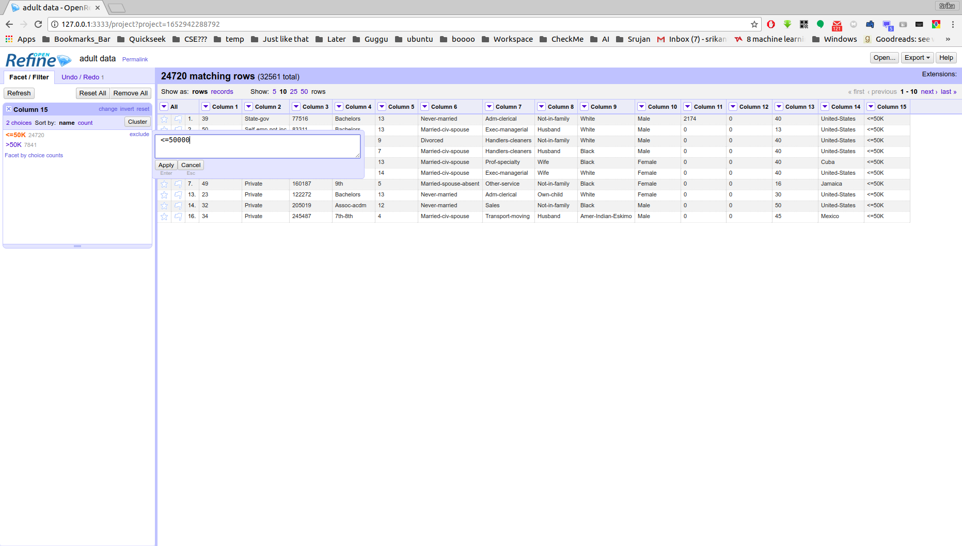
3.No Dates

4.Missing values deletion
One option is to delete all these rows(recommended for this data-set), but, to demonstrate another method...(filling down)
Column-Menu>Edit Cells>Fill Down
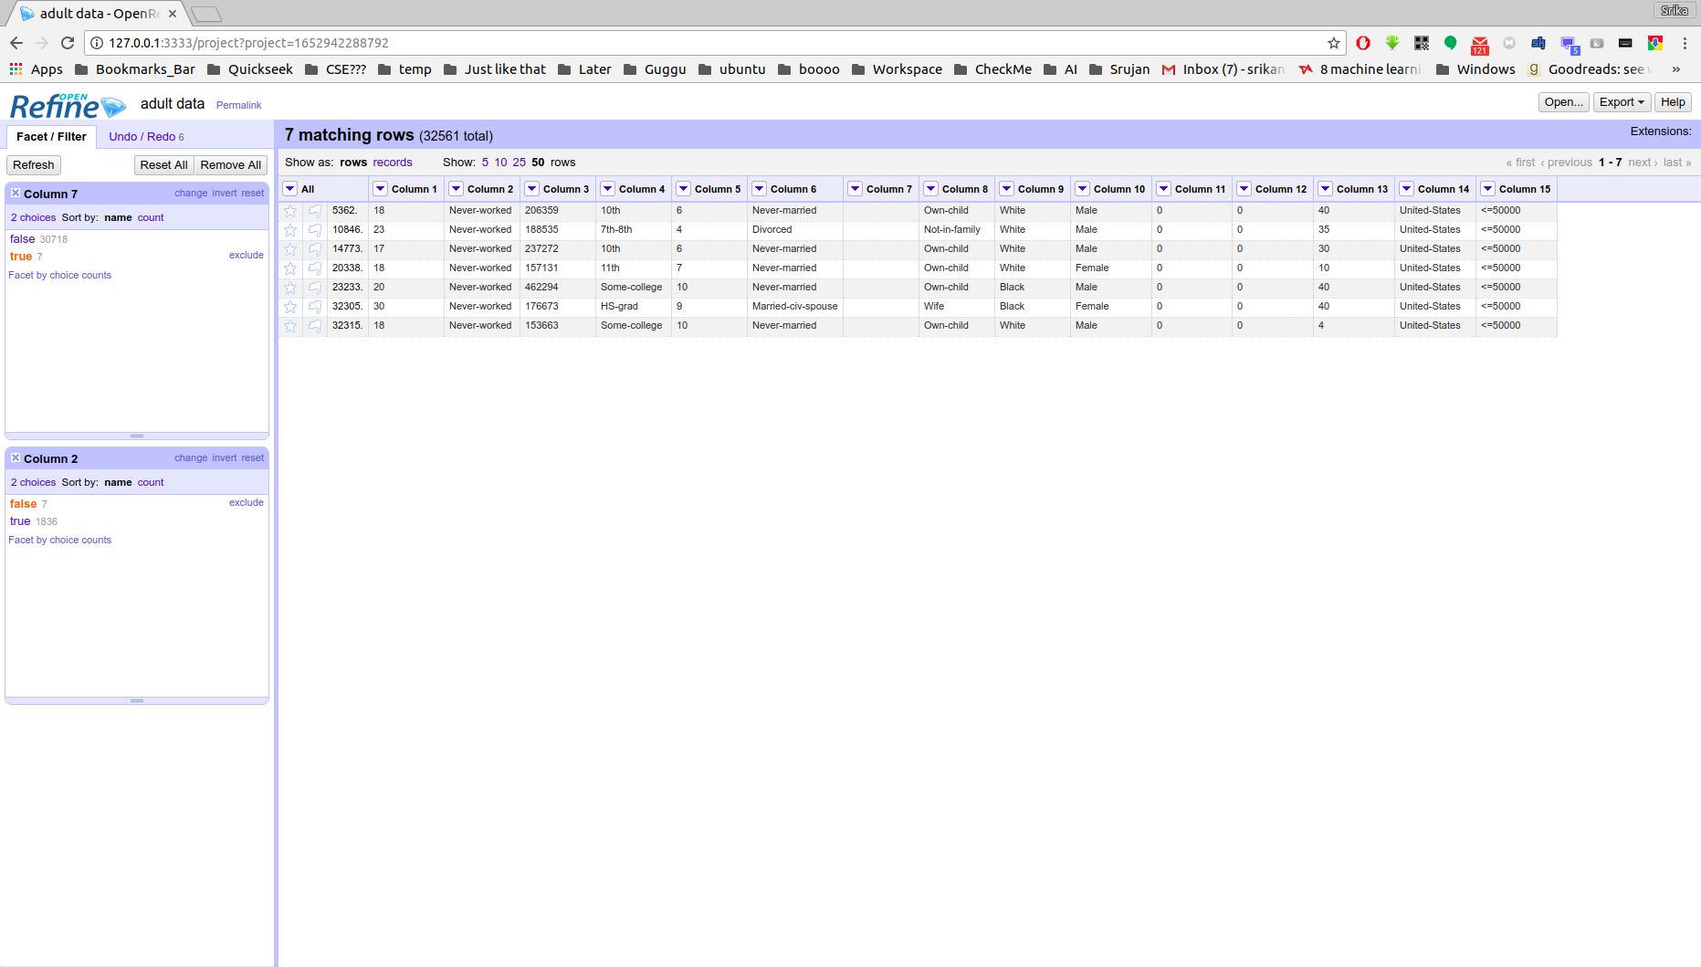
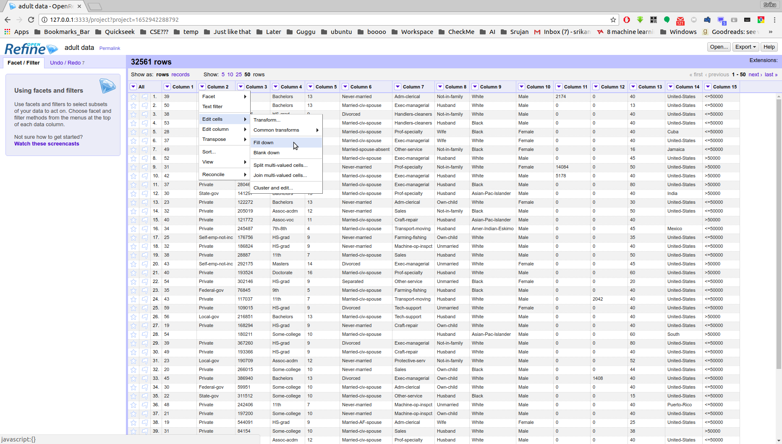

5.This data-set has no criteria to differintiate duplicates, in-fact, no duplicates were found(even based on column 3(fnlwgt))

6.Scatter-plot(for numbers) can be found in Column-Menu>Facet>Scatterplot facet(here, I have taken into account with respect to CLASS label)
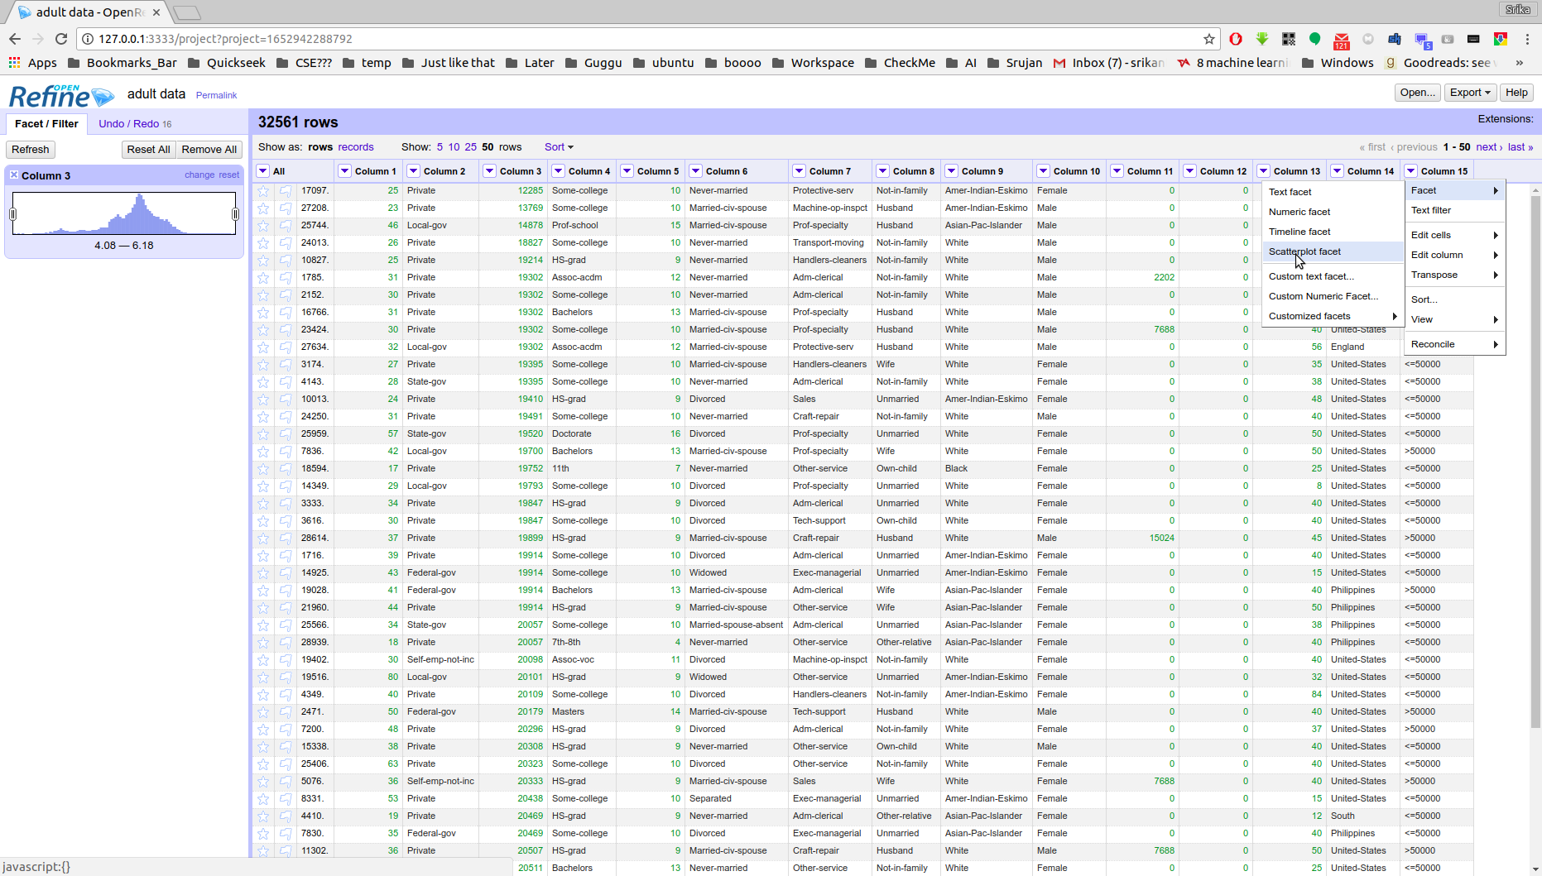
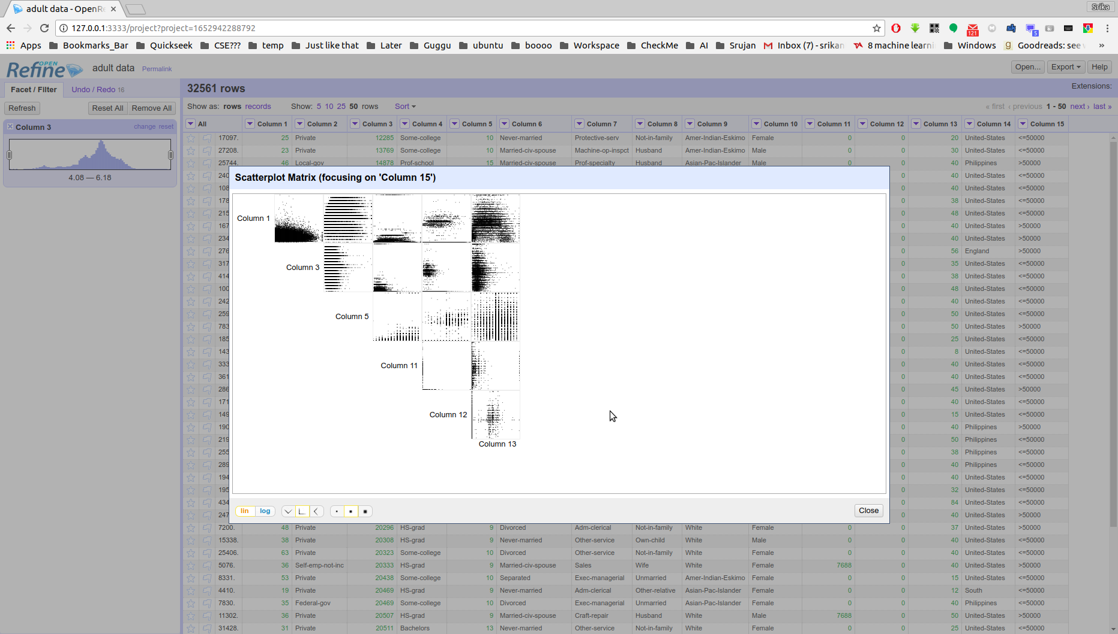

Selecting any of these plots, we can have a detailed look on them
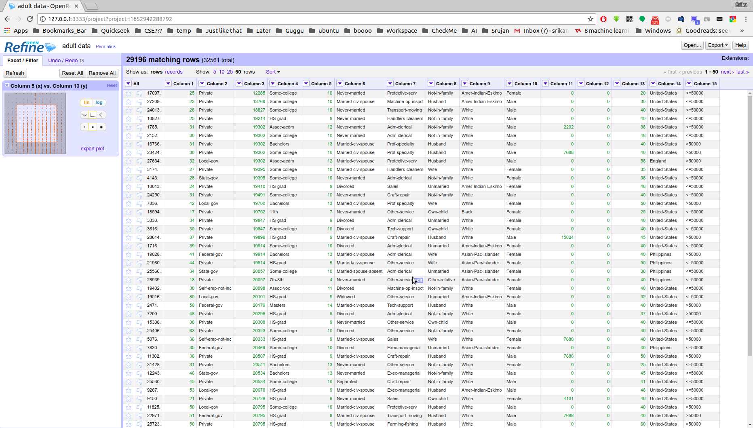
Select a region to access those records.

7.Finaized Data,(Cleaned) can be exported by option given to export
